**Support Vector Machines**

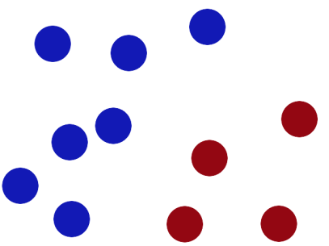

Figure 1 We have 2 colours of balls on the table that we want to separate.

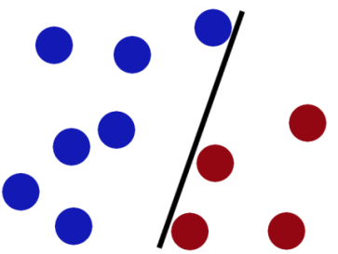

Figure 2 We get a stick and put it on the table, this works pretty well right?

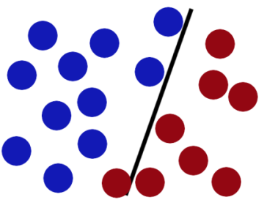

Figure 3 Some villain comes and places more balls on the table, it kind of works but one of the balls is on the wrong side and there is probably a better place to put the stick now.

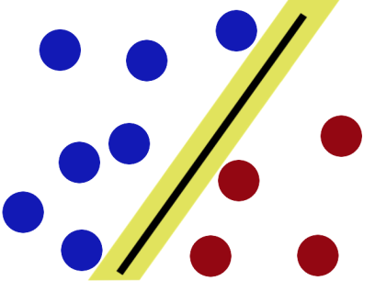

Figure 4 SVMs try to put the stick in the best possible place by having as big a gap on either side of the stick as possible.

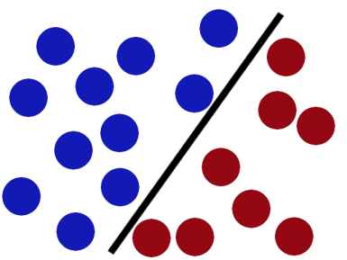

Figure 5 Now when the villain returns the stick is still in a pretty good spot.

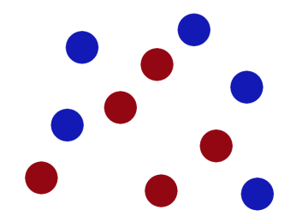

Figure 6 There is another trick in the SVM toolbox that is even more important. Say the villain has seen how good you are with a stick so he gives you a new challenge.

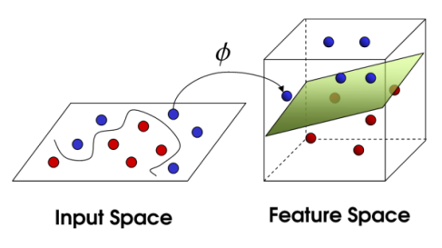

Figure 7 There’s no stick in the world that will let you split those balls well, so what do you do? You flip the table of course! Throwing the balls into the air. Then, with your pro ninja skills, you grab a sheet of paper and slip it between the balls.

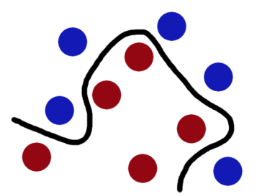

Figure 8 Now, looking at the balls from where the villain is standing, they balls will look split by some curvy line.

Boring adults call the balls **data**, the stick a **classifier**, the biggest gap trick **optimization**, call flipping the table **kernelling** and the piece of paper a **hyperplane**.

Bottom of Form

[[–]](javascript:void(0))[tangerinemike](https://www.reddit.com/user/tangerinemike) 3 points 3 years ago

Top of Form

One other thing: Once we've found the best place to put the stick or the paper, we realise that we can figure out that best place from just a few of the closest balls to the stick/paper and most of the other balls are unhelpful.

We call these important balls- support vectors.

Bottom of Form

[[–]](javascript:void(0))[zenogantner](https://www.reddit.com/user/zenogantner) 2 points 3 years ago

Top of Form

Nice explanation. Just for consistency: Adults call both the stick and the sheet of paper "separating hyperplane".

Bottom of Form